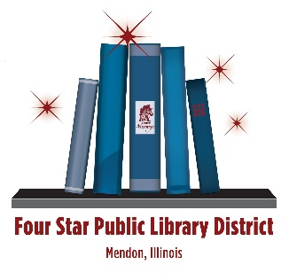

132 West South Street

Mendon IL 62351

217-936-2131

[fourstarpld@gmail.com](mailto:fourstarpld@gmail.com)

November 22, 2024

**ILA Inclusive Travel Grants for National Conferences Application for 2025**

I am eager to attend the 2025 Association for Rural & Small Libraries (ARSL) Conference in Albuquerque, NM, to enhance my ability to serve my community through inclusive and equitable library services. Aligning with the Illinois Library Association’s Statement of Commitment to Diversity, Equity, and Inclusion, I am committed to creating a welcoming environment where everyone has access to resources, opportunities, and programs that reflect their unique identities and experiences.

The ARSL Conference’s focus on addressing the needs of rural and small libraries presents a valuable opportunity to deepen my understanding of how to cultivate equitable library practices in resource-limited settings. I am particularly interested in sessions that explore strategies for reducing barriers to access, amplifying underrepresented voices, and developing culturally responsive programming. Networking with library professionals from diverse communities will provide fresh perspectives and innovative solutions to apply locally.

I hope to gain actionable insights on how to design services and spaces that actively embrace the diversity of rural populations, including traditionally marginalized groups. Additionally, I aim to learn how to foster partnerships that advance equity within the broader community.

By attending the ARSL Conference, I will be better equipped to build a library that champions inclusion, celebrates cultural differences, and empowers all individuals to thrive. I look forward to bringing back ideas and strategies to ensure our library continues to be a vibrant, inclusive, and equitable space for lifelong learning and community growth.