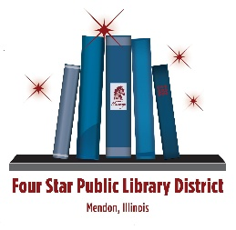
Four Star Public Library District
Regular Monthly Meeting
May 13, 2026 – 7:00 PM
- Call to Order
- Roll Call
- Recognition of Visitors
- Approval of Consent Agenda
Items listed under the consent agenda are considered routine and will be enacted by one motion.
“Does anyone want to remove any items in the consent agenda? Then I’ll need a motion and a 2nd, as well as a roll call vote
  - Approval of Minutes – April 15, 2026
  - Approval of Closed Session Minutes – September 20, 2024
  - Payment of the Bills - $13,813.81 and $1,080 for mortgage
  - Approval to continue to participate in IL Non-Resident Card program and set fees at $50/individual and $140/family
- Librarian’s Report
- Report of Committees
- Communications
  - Tracy Family Foundation grant – applied 5/1/26
- Unfinished Business
  - Evaluations - IP
  - Other
- New Business
  - First draft of Meeting Room Reservation Policy
  - Other
  - Discuss ILA’s Standards for Illinois Public Libraries Programming Action Plan
- Closed Session
“The Board of Trustees will recess into closed session pursuant to the Ralph M. Brown Act (Government Code Section 54960 et seq.) for purposes of the discussing and taking action on the following items:[insert]
“I move that the board hold a closed meeting to discuss pending, probable, or imminent litigation.”
  - Roll call vote to enter Closed Session
  - Vote to exit Closed Session
- Adjournment - “There being no other business, I delcare the meeting adjorned.”
Next Regular Meeting – June 10, 2026

